

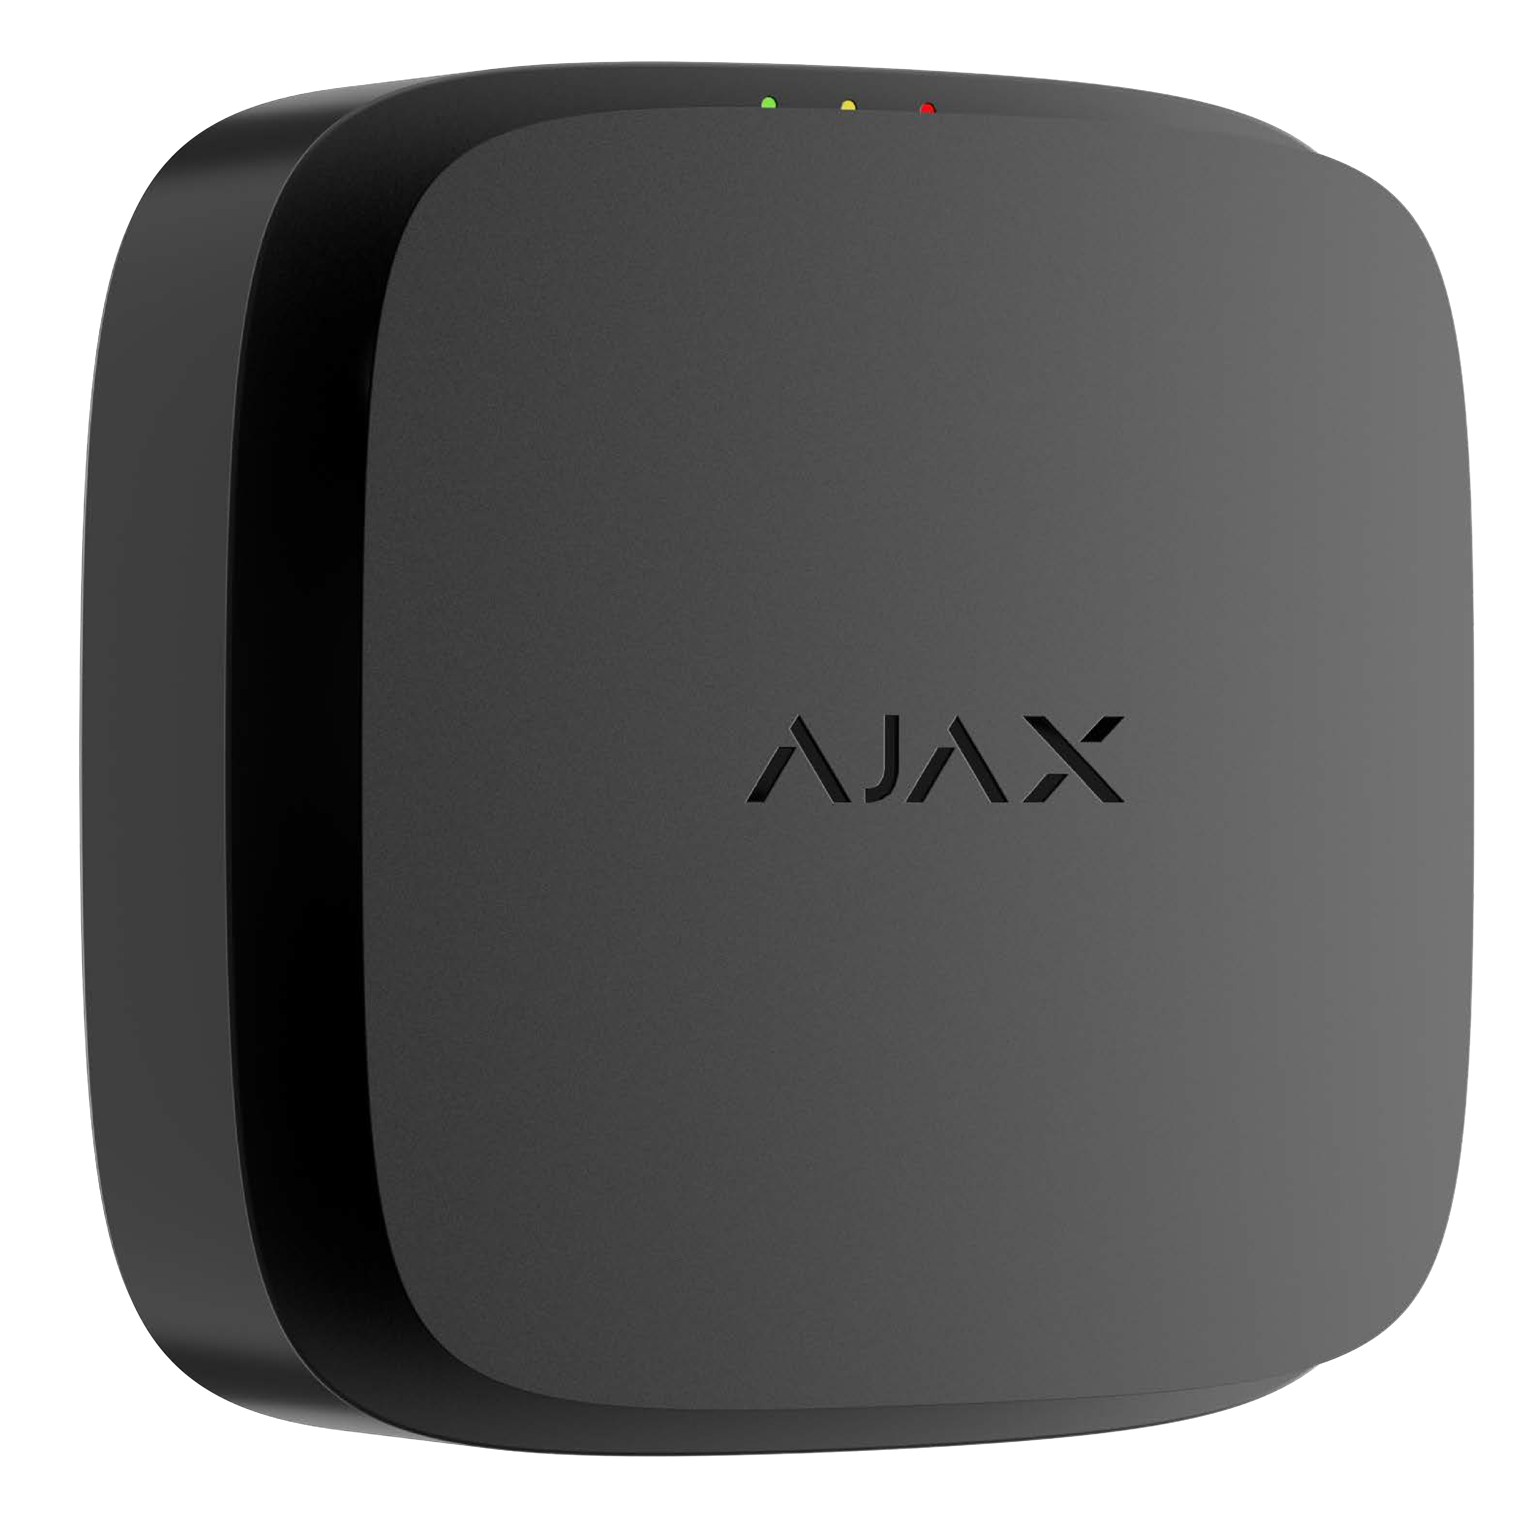

Baseline product line

EN
54-5:2017
A1:2018


FireProtect 2 AC Heat/CO

EN
50291-1
2018

Jeweller

Grade D1
BS 5839
part 6
Wireless mains-powered fire detector with heat and CO sensors

Accurate fire detection
-

Heat sensor CO sensor

- Two A1R-class thermistors are located outside the enclosure to eliminate detection delays
- Alarms when the temperature increases by 10°C within a minute or exceeds +64°C
- Accurately detects the CO level for up to 10 years

- Warns when concentration reaches the dangerous level of 50 ppm, before the first signs of poisoning occur


Power supply

The detector is powered by 110-240 V~ mains and includes a sealed backup battery. Even in a power outage, the detector continues to operate, ensuring quick and reliable fire detection throughout its 10-year lifespan.

o-o

\■/ Enhanced wireless interconnection
0

AC detectors can synchronously notify of a fire alarm through primary (via Ajax hub) and fallback (detector-to-detector) interconnections. In case of alarm, the hub activates the primary interconnection in 20 s. All information is instantly available
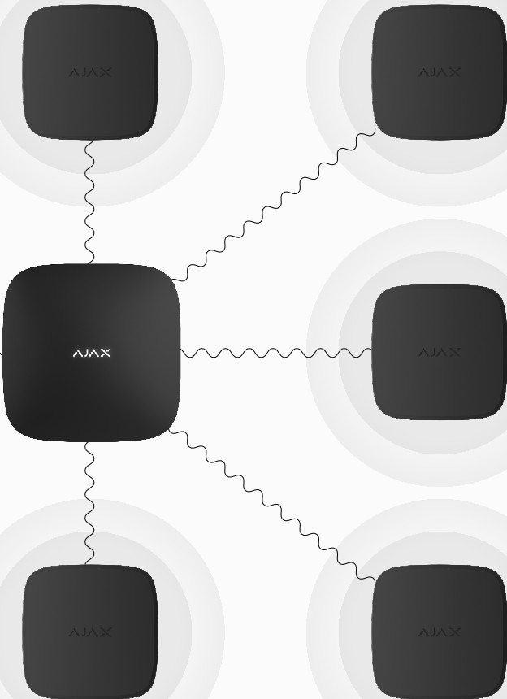
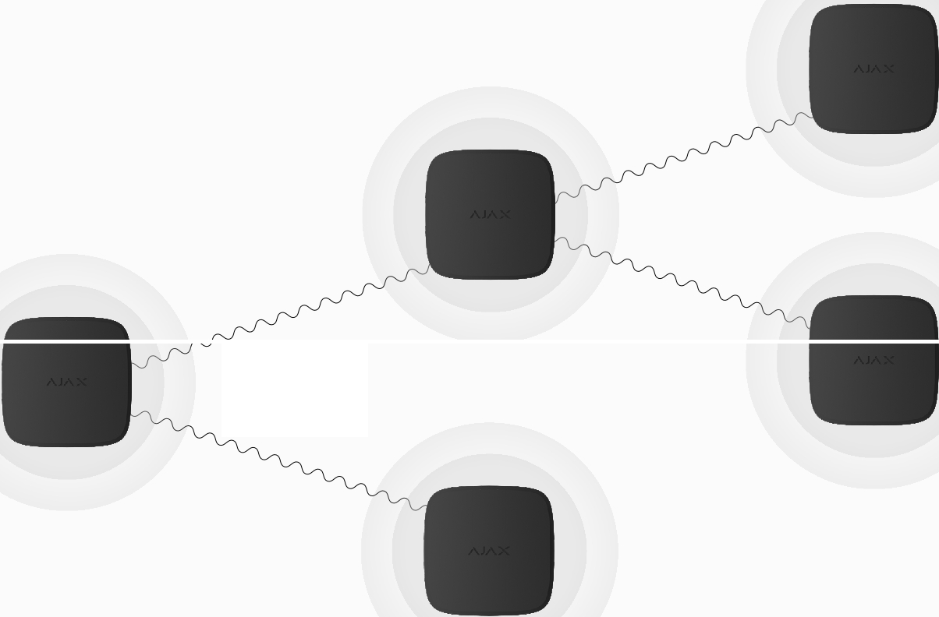
in Ajax apps: initiating detector's location, fire alarm type, and exact time. Meanwhile, the initiating detector activates the fallback interconnection. Even if the connection with the hub is lost, raising the interconnected alarm takes only a minute.
Fire alarm!


vvvvi;i IB!'ll'IY J J·

System supervision Additional features
-
CB

- Regular polling of each system device to display current statuses in apps
- Automatic detector self-diagnosis with state reporting to the hub
- Up to 1,700 m of wireless communication and twice as much with a range extender
- Instant maintenance notifications
- Automation scenarios activation

- Visual alarm verification using MotionCam detectors or any NVR camera
- Indoor/outdoor intrusion sirens activation

- Alarm delivery to CMS

- Built-in 85 dB siren

- LED indication of detector states

Quick installation and setup

- SmartBracket panel to mount the device without disassembling the enclosure

- Removable WAGO 221 connectors to secure the wires without a screwdriver

- A lock to secure the device on SmartBracket

- Pairing with a hub via QR code, with remote control and configuration in the app

Superior, Fibra, and Baseline product lines are mutually compatible. This opens up numerous possibilities for building systems of any configuration.

Compliance | Compatibility | Communication with hub | Power supply
EN 54-5:2017+A 1:2018  EN 50291-1:2018 | Hubs  Hub Plus, Hub 2 (2G), Hub 2 (4G), | Jeweller communication technology | Main  110-240 V~, 50/60 Hz
BS 5839 (part 6, grade D1) | Hub 2 Plus, Hub Hybrid (2G), |  | Up to 2 W of mains power
 | Hub Hybrid (4G) | Frequency bands | consumption
 |  | 866.0-866.5 MHz
 | Range extenders | 868.0-868.6 MHz | Backup battery
 | Rex, Rex 2 | 868.7-869.2 MHz | 1 x CR 2/3 AA
 |  | 905.0-926.5 MHz | Sealed
 |  | 915.85-926.5 MHz
 |  | 921.0-922.0 MHz
 |  | Depends on the sales region
 |  | Communication range
 |  | up to 1,700 m
 |  | In an open space
Installation | Enclosure | Complete set
Operating temperature range  from 0°C to +50°C  Operating humidity  up to 80% | Colour  black, white  Dimensions  122 x 122 x 54 mm  Weight  305 g | FireProtect 2 AC (Heat/CO) Jeweller  SmartBracket mounting panel  - x CR 2/3 AA battery (sealed)  - x WAGO 221-3 connector (pre-instaIled)  Installation kit Quick start guide


For detailed information, scan the QR code or follow the link:
-[!]
•

ajax.systems/support/devices/fireprotect-2-ac-heat-co/

Iii support@ajax.systems
◄ @AjaxSystemsSupport_Bot
(ill) ajax.systems

