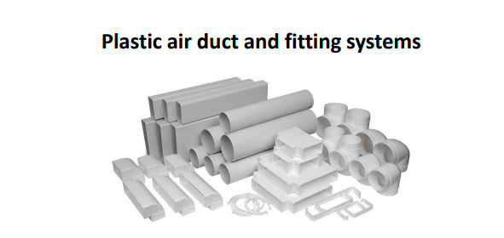
Description
Plastic air ducts and fittings systems for supply and exhaust ventilation of premises. The system is quick, easy and clean, assembled without sealants or fixation, can be installed and used in any climate, reducing operating costs.
Made from plastic.
Sizes: rectangular 110x55, 220x55 and 220x90 mm, round Ø100, Ø125 and Ø150 mm.
Duct lengths from 500 to 1500 mm.
Technical specifications
System | Extraction performance | Temperature range
110x55 / Ø100 mm | Up to 250 m³/h | -5°C … +60°C
220x55 / Ø125 mm | Up to 600 m³/h | -5°C … +60°C
220x90 / Ø150 mm | Up to 900 m³/h | -5°C … +60°C

